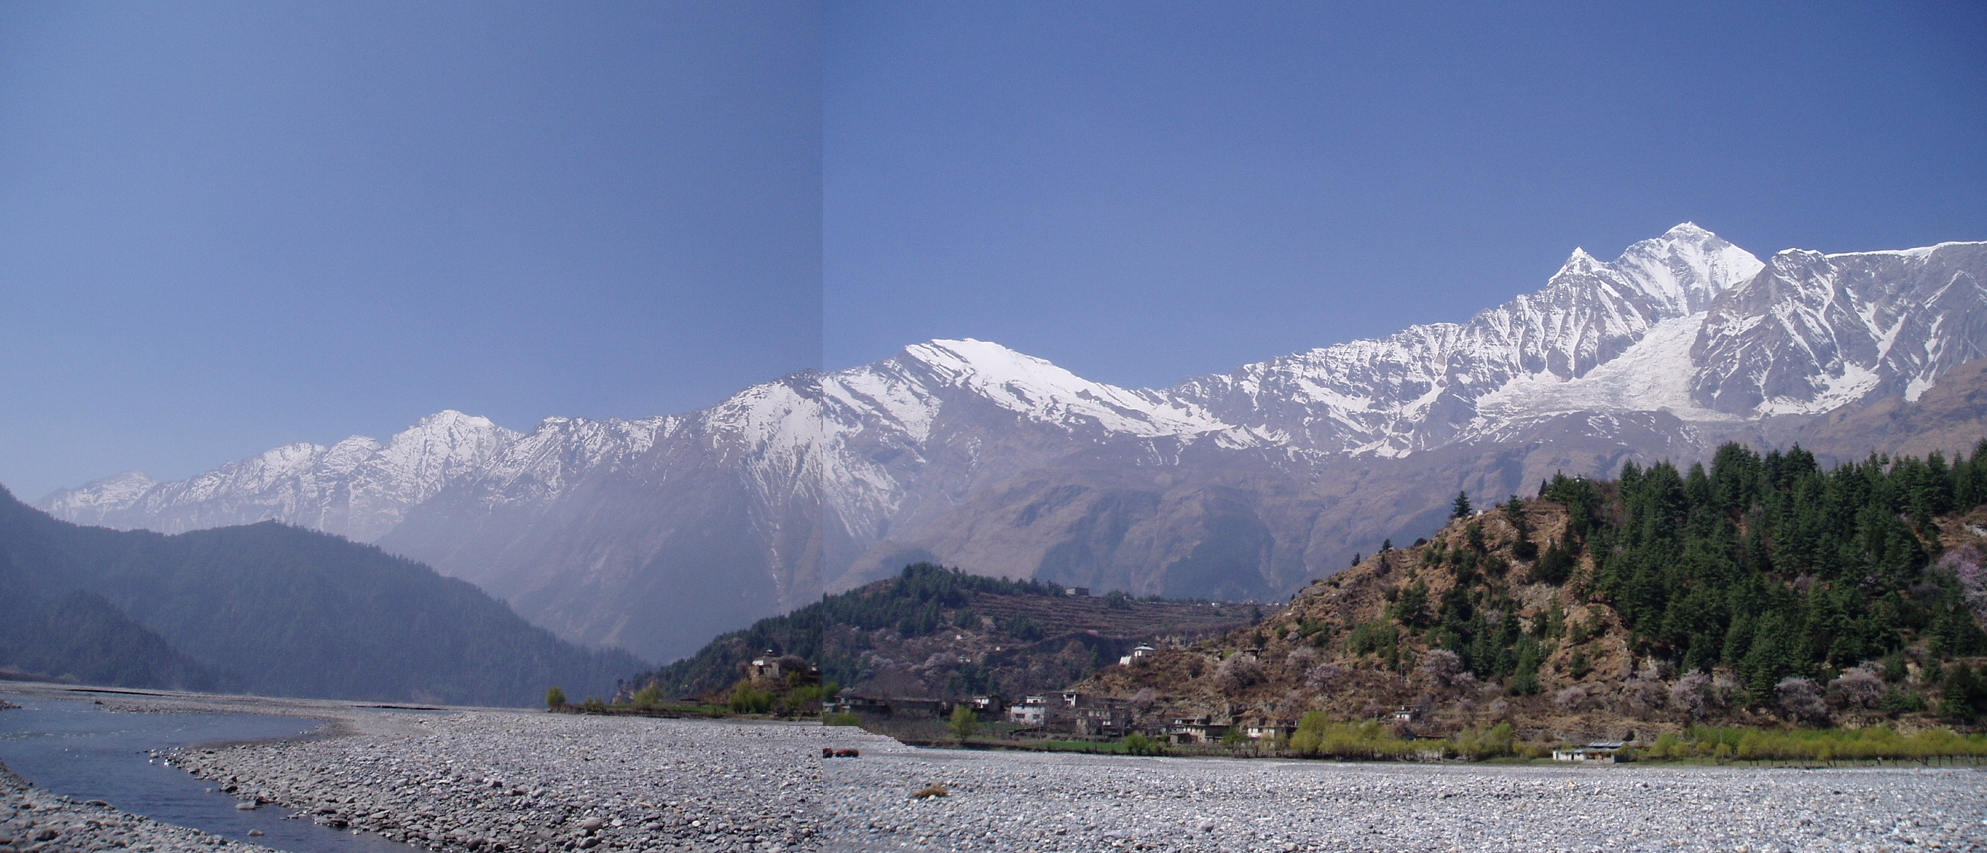

The Ninth Student Himalayan Exercise Tour
-Call for Participants-
In March 2020, 13 days with less than 1200 USD
(Recommended by six academic societies including the International Association for Gondwana Research, Nepal Geological Society, Geological Society of Japan etc)

Studying the true nature of an Orogen in the Himalaya!
The tour covers the course Kathmandu-Pokhara-Muktinath-Pokhara-Lumbini-Kathmandu using a chartered bus or jeeps. More than 30 Japanese and Nepalese geoscientists who are familiar to the Himalaya are registered to voluntarily work as a geo-guide and tour leader to show students in the field the beautiful Himalayan geology and nature. All necessary expenses including lodgings, foods, chartering vehicles, employing sherpas etc are included in the above cost. Some Japanese and Nepalese universities decided or are under consideration to give a curriculum point to participated students.
Program* of this exercise tour started in 2012 and the 2020 tour is the 9th tour. A report e-book (mostly in Japanese with some English summaries) assembling reports by all participants has been published every year and that of the SHET-8 is served for free downloading by the URL below.
https://www.data-box.jp/pdir/a43d8b32a8744aa1b6fdfcf5bba91666

Application for participation and/or inquiries:
Please contact Prof. Masaru Yoshida with the following addresses.
Gondwana Institute for Geology and Environment,
147-2 Hashiramoto, Hashimoto 648-0091, Japan Tel & Fax: 0081-(0)736-36-7789
E-mail: gondwana@oregano.ocn.ne.jp

Outline of the tour (Details can be downloaded from the above URL)
<Period of application> 10th May 2019 – 31st December 2019
<Period of the tour> 5th – 17th March 2020, 13 days (from Kathmandu to Kathmandu)
<Participation fee> Less than 1200 USD per one student. Citizens are requested to add 300 USD, and those who are officially dispatched from organizations are requested to add 500 USD on the student’s cost. The real cost is found on the last day of the tour and the balance will be refunded on that day.
<Deadline and method of payment> The participation fee (provisional cost of 1200 USD for a student) should be paid on the 5th March 2020 by cash.
____________________________________________________________________________
* http://www.gondwanainst.org/geotours/Studentfieldex_index.htm

